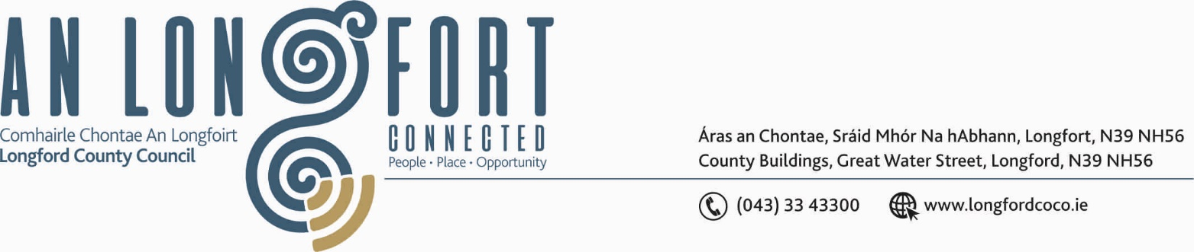

GRANARD MUNICIPAL DISTRICT

22nd July 2020.

To: Each Member of Granard Municipal District.

Dear Member,

You are requested to attend Meeting of Granard Municipal District to be held in
the Granard Community Library on Tuesday, 28th July 2020 at 3.00 p.m. to transact business, as set out on the Agenda hereunder.

Yours sincerely,
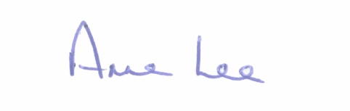

_______________
Anne Lee,
Meetings Administrator.

AGENDA

Prayer before meeting.

1. Confirmation of Minutes of the following Granard Municipal District Meetings -
(i) MD Meeting held on the 12th May 2020.
(ii) Annual Meeting held on the 23rd June 2020.
- copies enclosed

2. Matters arising from Minutes.

3. Declaration of Interest by Members.

4. Management Report incorporating Area Engineer’s Progress Report
(to follow)

5. Granard Public Art Features.

6. 2020 Community Grant Support Scheme – including Town Twinning.

7. 2020 Special Projects Fund and Members Discretionary Fund.

8. Correspondence received from Granard Pitch & Putt Club – enclosed.

9. Notice of Motion submitted by Councillor Seamus Butler to the March meeting of the County Council -

“That Longford County Council should provide serviced overnight facilities for RUVs and camper vans. This will mitigate against the blight of such vehicles causing nuisance by parking in public areas such as Clondra Harbour. It will also attract a category of tourist that is not currently catered for adequately in the County.”

It was agreed that this Notice of Motion be referred to each of the Municipal Districts for consideration of possible sites in their area.

10. Notices of Motions, submitted by Councillors, as listed hereunder –

Councillors Colin Dalton and Paraic Brady.

“We call on Longford County Council to consider providing seating at the scenic walkway on Cairn Hill.”

Councillor Paraic Brady

“That repairs be carried out to the wall and paths in the new Cemetery in Ballinamuck, as they are in need of some repair .”

Councillor Turlough McGovern.

“When drafting Town Plan for Granard, that two loading bays be marked out on the Main Street, on each side, as lorries have to double park on the Main Street. Therefore, causing serious traffic congestion and major delays in the town.”

Councillor Garry Murtagh

“Significant signage at Esker Cross as a noted landmark referenced on the Tain Trail - Cairn Hill Killoe.”
“Replacement sign at Cranniur Estate in Enybegs Killoe.”

“I am calling on Longford County Council to write to Heather Humphreys, Minister for Social Protection, Community and Rural Development and the Islands, for consideration of changes to the Local Improvement Scheme (LIS).

Altering farming measures in rural Ireland and, in particular, the resurgence of dairy farming means that farmers have to increase their holdings in order to be sustainable, they have to acquire large sways of land thus leading to the demise of small farm holders which in turn has a negative impact on LIS applications.

Current legislation demands that “Projects, which provide access to parcels of land of which at least two are owned or occupied by different persons, engaged in separate agricultural activities. (Proof of two landowners must be provided)”
So where beneficiaries (house-holders on a private lane) are contributing to the LIS, they are not being considered as part of the qualifying criteria.
I feel the rules regarding the LIS need to be adjusted to coincide with the evolving changes in rural Ireland. This scheme is a vital resource in the protection, support and preservation of an invaluable infrastructure that is the network of rural Ireland.”



